**Crystal methods**

**Crystal methods in Agile Development/Framework:** The crystal method is an agile framework that is considered a lightweight or agile methodology that focuses on individuals and their interactions.

The methods are color-coded to significant risk to human life. It is mainly for short-term projects by a team of developers working out of a single workspace.

Two core beliefs of the Crystal method:

* Find your own way and methods to optimize workflow.
* Make use of unique methods to make the project unique and dynamic.

**He concluded that the suitability of the Crystal method depends on three dimensions:**

* First, Team size.
* Second, Criticality.
* Third, the priority of the project.

**How does Crystal function?**

Till now, we got to know that crystal is a family of various developmental approaches, and it is not a group of prescribed developmental tools and methods. In the beginning, the approach is set by considering the business requirements and the needs of the project.

Various methodologies in the Crystal family also known as weights of the Crystal approach are represented by different colors of the spectrum.

Crystal family consists of many variants like Crystal Clear, Crystal Yellow, Crystal Red, Crystal Sapphire, Crystal Red, Crystal Orange Web, and Crystal Diamond.

1. **Crystal Clear-** The team consists of only 1-6 members that is suitable for short-term projects where members work out in a single workspace.
2. **Crystal Yellow-** It has a small team size of 7-20 members, where feedback is taken from Real Users. This variant involves automated testing which resolves bugs faster and reduces the use of too much documentation.
3. **Crystal Orange-** It has a team size of 21-40 members, where the team is split according to their functional skills. Here the project generally lasts for 1-2 years and the release is required every 3 to 4 months.
4. **Crystal Orange Web-** It has also a team size of 21-40 members were the projects that have a continually evolving code base that is being used by the public. It is also similar to Crystal Orange but here they do not deal with a single project but a series of initiatives that required programming.
5. **Crystal Red-** The software development is led by 40-80 members where the teams can be formed and divided according to requirements.
6. **Crystal Maroon-** It involves large-sized projects where the team size is 80-200 members and where methods are different and as per the requirement of the software.
7. **Crystal Diamond & Sapphire-** This variant is used in large projects where there is a potential risk to human life.

The below figure illustrates about crystal team

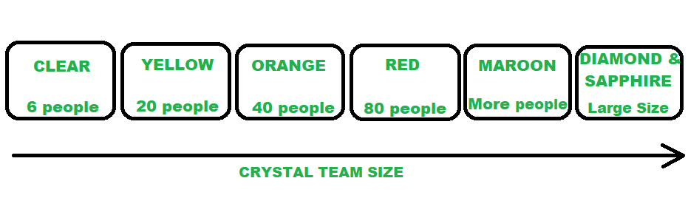

*CRYSTAL FAMILY (TEAM MEMBERS)*

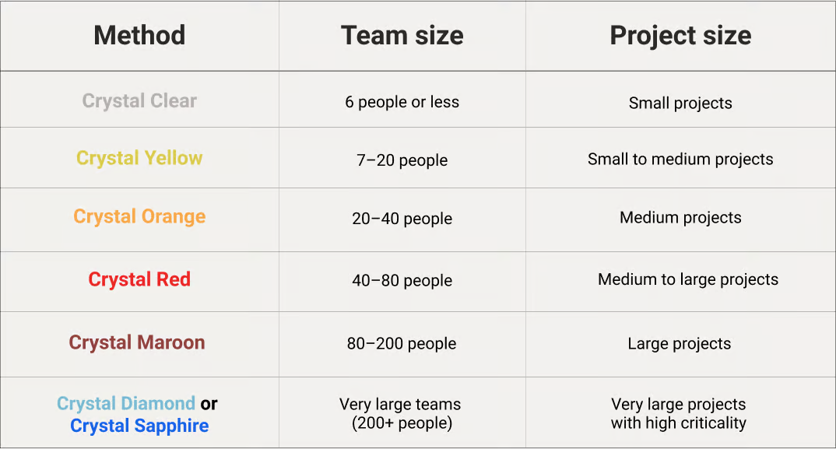

**Benefits of using the Crystal Agile Framework :**

* **Faster delivery –** The framework enables the team to deliver working software faster, which can help gain a competitive advantage in the market.
* **Higher quality –** The framework emphasizes on quality, enabling the team to detect and fix defects early in the development process, resulting in a higher quality product.
* **Improved customer satisfaction –** The framework promotes customer involvement, enabling the team to deliver products that meet customer needs, resulting in higher customer satisfaction.
* **Increased productivity –** The framework enables the team to focus on delivering the highest value features, which can increase productivity and reduce waste.